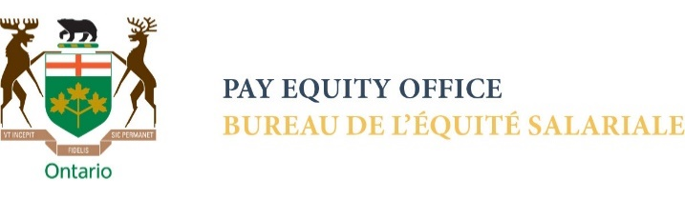
Ep4: Care and “domestic” bias

Kadie Ward (KW): The OECD, the Organisation for Economic Cooperation and Development, has estimated that the time spent on unpaid care work to be approximately 15% of GDP. So, I like that you've made the distinction there. And could be up to 27% when opportunity costs of workers doing unpaid care and domestic work at home were accounted for, right? So that's what we're talking about, this the sort of opportunity costs which translate to a larger gender wage gap. They also noted that women, and this is from a recent report, women create the majority of this economic value, this 15% GDP. How might this imbalance with women dominating unpaid care impact our perception of how we value the care economy?

Katherine Scott (KS): There's a large economic literature on this question, and you've probably reviewed it in your podcast around the importance of the gender division of care labour, unpaid labour and women's responsibilities for unpaid care and how that impacts our participation in the paid labour market, and as well their representation in care work that impacts the value we attach to their paid labour and in particular their paid care labour, which is undervalued in comparison to other occupations in the labour market. The whole question of unpaid care and work is hugely important. And this of course covers everything involved in physical reproduction, whether that's for care in the home, like whether that's cleaning and shopping and provisioning, doing the tasks of care for children or elders or those with disabilities and the like, but it also of course includes other dimensions: the mental and emotional labour that's involved in managing the household and figuring out how to stretch a budget to cover, to feed your children well, to secure good housing or services, or making all of those doctor's appointments, and so forth. There's a huge additional component to unpaid work that's not always acknowledged, and again, very gendered, it's women taking on these roles. And of course, these roles are fundamental not only to the operation of our families, they're fundamental to our family life, but they're fundamental to our economy and to our broader society. And they are often overlooked and undervalued, as you've said. In large part because they are seen as women's natural domain, as women's natural care labour. They're invisible. I guess I would say in terms of where we are and how important this question is certainly for the care economy, it's precisely the lack of recognition for women's work and women's care work. I think, or I would argue that's at the heart of much of the tension that we're experiencing right now in the care economy.

OUTRO

