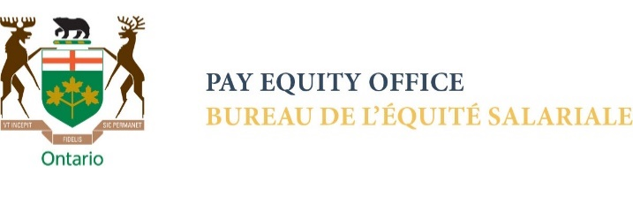
Ep6: Confronting bias
to close the
gender wage gap

Anthony Greenwald: I wouldn't call disparity finding a preventive approach. It's actually an epidemiological approach because it uses the methods that epidemiologists, medical specialists who are usually great statisticians, look to find evidence for healthcare disparities. And what they do is they just look everyone they can find, sort them into demographic categories based on age, based on gender, based on race, based on socioeconomic status, and say, okay, who has this problem more than others? And generally, they find it's not equal among all. So, when you look for healthcare disparities, you generally find them, although you may not know exactly what ones you're going to find. And then a question is: is this something that we should be worried about? And if so, what do we do with it? And the first question, should we be worried about it, is probably the one that should be asked first. Because there are some disparities that you're going to find that have non-discriminatory explanations. And so an epidemiologist will look for that. And you can find epidemiological research on healthcare disparities in which they've said, yeah, this is a difference we've observed, but actually there's this explanation that we have over here, and we found that yeah, this isn't something that we need to worry about because there's a reasonable explanation that is not discriminatory. So that's part of the epidemiological approach now, and I think that's the more powerful approach, I call that method that can be used in the workplace and other discrimination as disparity finding. That's what epidemiologists do when they're looking for healthcare disparities. You can similarly look for disparities in outcomes to employees in the workplace or in other settings because it's not just limited to employment. Disparity finding is just a straightforward statistical exercise. It's not totally trivial and epidemiologists need skills to do it properly, but it is so easy to do, much easier to do than implicit bias training, for example. Probably less expensive also. So that's my main advice.

Kadie Ward: It's a great piece of advice, and I think it's something that especially large employers who have that type of information generally at hand can start to learn. And I think we're going to share this article.

OUTRO

